Cohesion and coherence

Connections in texts: cohesion
We looked at how a text is joined together by references and connecting words. If these connecting words are used well the text makes sense. This can be called cohesion, and the connecting words and phrases are often called 'cohesive devices'. A good way to think of them is that they are 'direction words', or 'signposts'. The writer uses them to guide the reader about which direction he or she is going in.

There are other cohesive devices, too: repetition, substitution, ellipsis and lexical cohesion.

***************************************************************************************

There is a difference between cohesion and coherence. They both relate to 'how the text hangs together', how much we feel that the text IS a whole text, how much sense the text makes.

A text is cohesive if its elements are linked together. A text is coherent if it makes sense.

Making sense: coherence
In other words, for any text, if we want to understand what's going on, beyond the simple mechanics of cohesion, we should ask the following questions:

Who is the writer?

Who is the intended audience?

What does the writer want the audience to do or think?

***************************************************************************************

The difference between cohesion and coherence
Cohesion describes the links within the text that connect one thing (one word or phrase) to another. We can analyse a text and say clearly whether it has or does not have cohesion, based on whether it has reference, repetition, subsitution, lexical cohesion, and so on.

Coherence is subjective. A text is coherent if the reader (or listener) can understand what the writer (or speaker) is trying to communicate. Therefore we cannot definitively say a text is or is not coherent, only that it is coherent for this reader/listener (or this group of readers/listeners).

Thus a text can be cohesive without being coherent, and vice-versa.

For example:

Q: If you have four pencils and I have seven apples, how many pancakes will fit on the roof?

A: Purple, because aliens don't have hats.

Each sentence is is well-formed, and the sentences seem to be linked together, but they don't make much sense. (This is partly because they have little lexical cohesion.) This sentence has (some) cohesion, but it is not coherent for me.

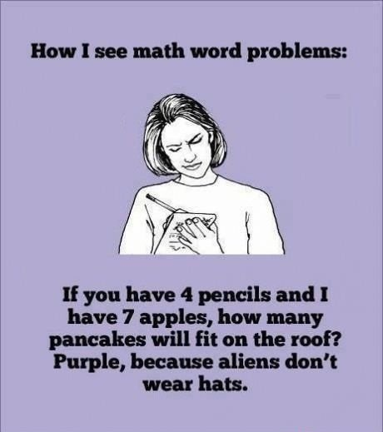
However, if we look at the wider context, we can, in fact, see what the writer is trying to communicate:

Scott Thornbury is one of the best writers on English grammar. he writes very simple and clearly, and here is his explanation of the two words:

http://www.onestopenglish.com/methodology/ask-the-experts/methodology-questions/methodology-coherence-and-cohesion/154867.article

***************************************************************************************

Cohesion and coherence come together when we ask:
What words, phrases, grammar, text organisation (including formatting) does the writer choose in order to achieve these aims?

***************************************************************************************

Here's another explanation of cohesion that might be useful, though it's a lot more technical. It also gives some background to functional linguistics

http://www.slideshare.net/cupidlucid/cohesion-in-english-presentation

