Pronunciation and the International Phonetic Alphabet

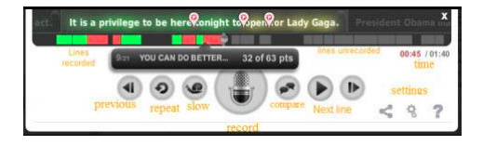
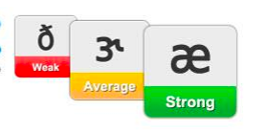
When you are recording your voice, doing the speaking part of English Central, you will see some red, yellow and green boxes under the words as you speak.
These colours tell you how well you are pronouncing the individual sounds. Red means your pronunciation is weak (not good); yellow means it is average, and green means that it is strong (very good).

When you have done the speaking part of English Central several times, you will be able to look at your pronunciation feedback from the ‘My class’ page.

The feedback will look something like this:
These are symbols of the International Phonetic Alphabet (IPA). This is a special kind of alphabet that can be used to represent the sounds of any language in the world. These are the IPA sounds that represent the 44 sounds of English.

- if your pronunciation feedback shows that you this symbol in red:

it means that your pronunciation of the sound “er” in “teacher” is not good.

- if the pronunciation feedback shows you this symbol in yellow:

it means that your pronunciation of the “m” sound in “man” is average, or not bad.

- if the pronunciation feedback shows you this symbol in green:

it means that your pronunciation of the “ow” sound in “cow” is very good.

You can start to practice pronunciation or by typing "pronunciation" in the search box in English Central, or by going here
https://www.englishcentral.com/search/videos?search=pronunciation

